

|  |  |
| --- | --- |
| **Name** | **Omar Abdelhady Mohamed Riad** |
| **ID** | **536** |
| **Group** | **4** |
| **SEC** | **34** |
| **Topic** | **Mobile Computing** |
| **Github Link** |  |
| **Github Page** |  |

|  |
| --- |
| **Examiners Committee** |
| **Dr.Ahmed Bayoumi** |
| **Dr.Shady Elmashad** |
| **Dr.Abdelhamid Attaby** |

# Screenshots:

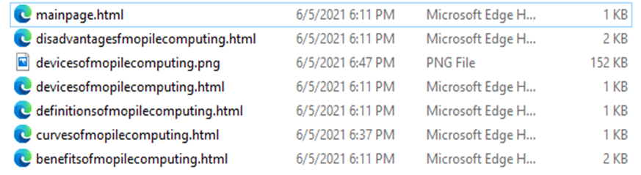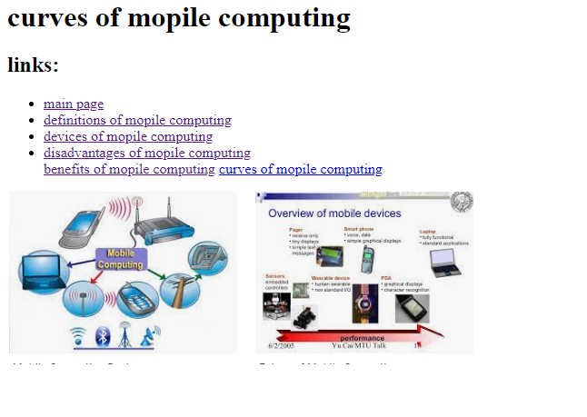

Source code:

1)

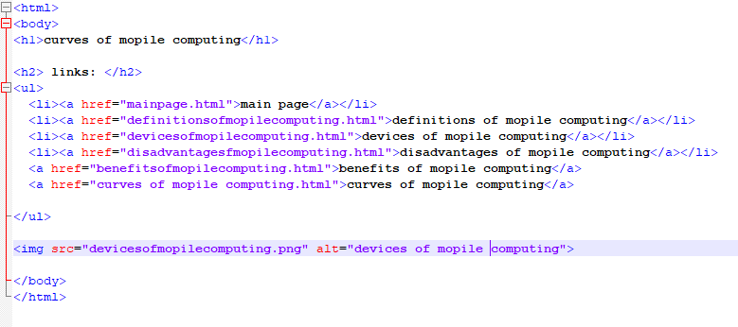2)

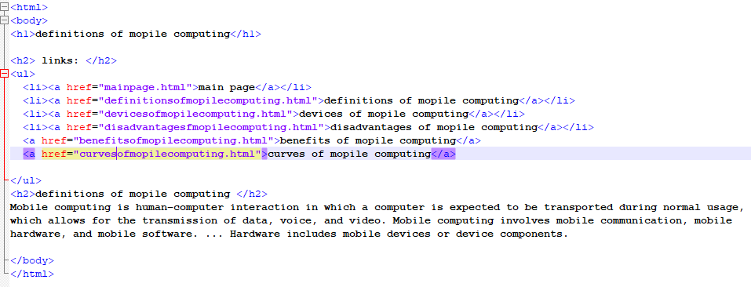3)

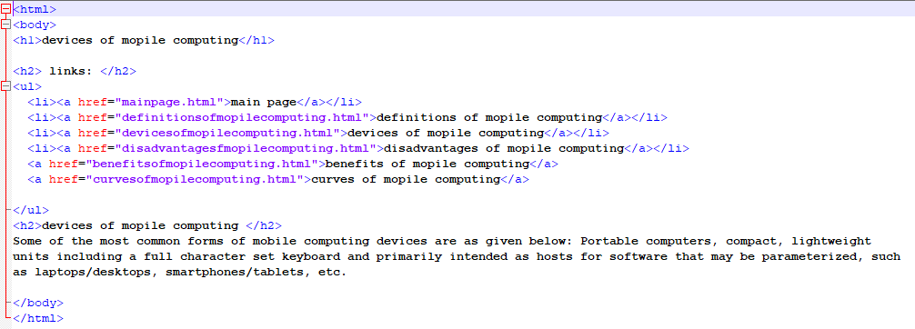

4)

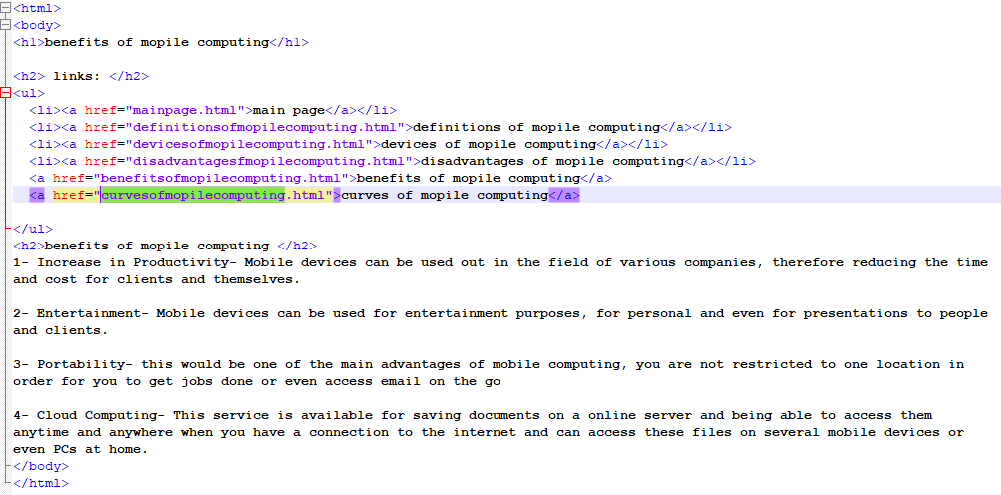5)

